**Ideation Phase**

**Empathize & Discover**

|  |  |
| --- | --- |
| Date | 27 June 2025 |
| Team ID | LTVIP2025TMID31213 |
| Project Name | Edututor-AI-personalized-Learning-withGenerative-AI -and-LMs-Integration |
| Maximum Marks | 4 Marks |

**Empathy Map Canvas:**

1. Customer Perspective: Understand the customer's thoughts, feelings, and behaviors.
2. Pain Points: Identify the customer's pain points and challenges.
3. Gains: Identify the customer's goals and aspirations.
4. Emotional Connection: Understand the customer's emotional connection to the problem or solution. Benefits
5. Deep Understanding: Gain a deep understanding of the customer's needs and pain points.
6. Human-Centered Design: Design solutions that are human-centered and empathetic.
7. Improved Customer Experience: Improve the customer experience by addressing their needs and pain points.

**Example:**

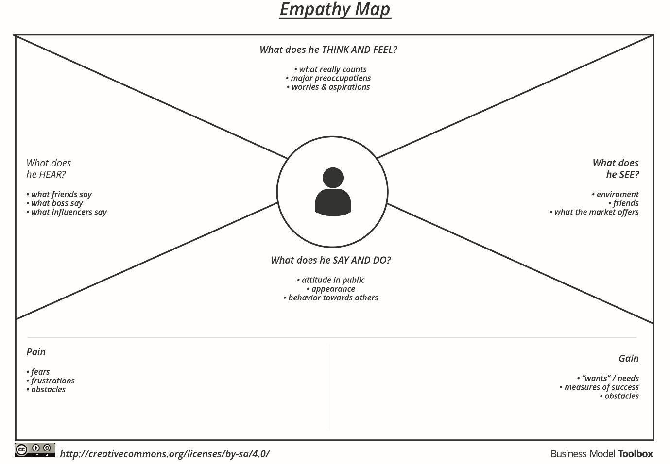

Reference: <https://www.mural.co/templates/empathy-map-canvas>

**Example: Food Ordering & Delivery Application**

